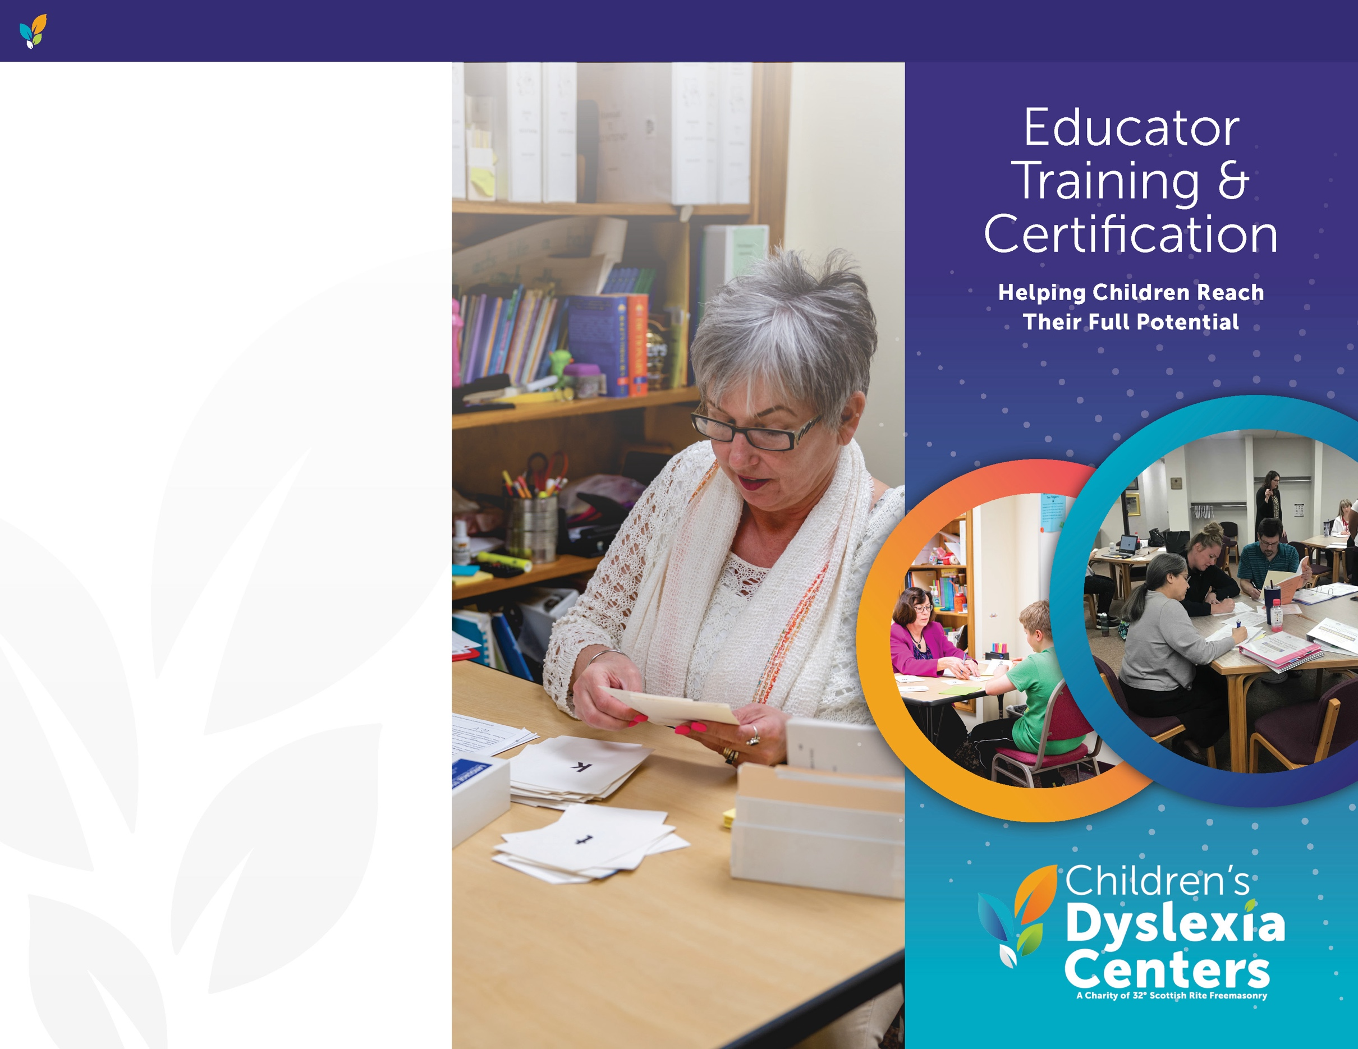

**FOR MORE INFORMATION,**

**PLEASE CONTACT**

**Center Name**

**Name, Title**

Phone

Email

Address

City, ST ZIP

**HOW THE CHILDREN’S DYSLEXIA CENTERS TRANSFORM LIVES**

The Children’s Dyslexia Centers, Inc. (CDC) began in 1994 as a partnership between the Scottish Rite, Northern Masonic Jurisdiction and Massachusetts General Hospital’s Language Disorders Unit to ease the life-long challenges of children with dyslexia. Since that time, the CDC has provided individualized instruction to children with dyslexia and graduate-level training for adults. Through support from the Scottish Rite Benevolent Foundation and grants, the CDC covers most of the cost of tutoring the children and training adults.

*The Children’s Dyslexia Centers, Inc.*

*is a tax-exempt 501(C)(3) charitable organization.*

**ChildrensDyslexiaCenters.org**

**CHILDREN’S DYSLEXIA CENTERS**

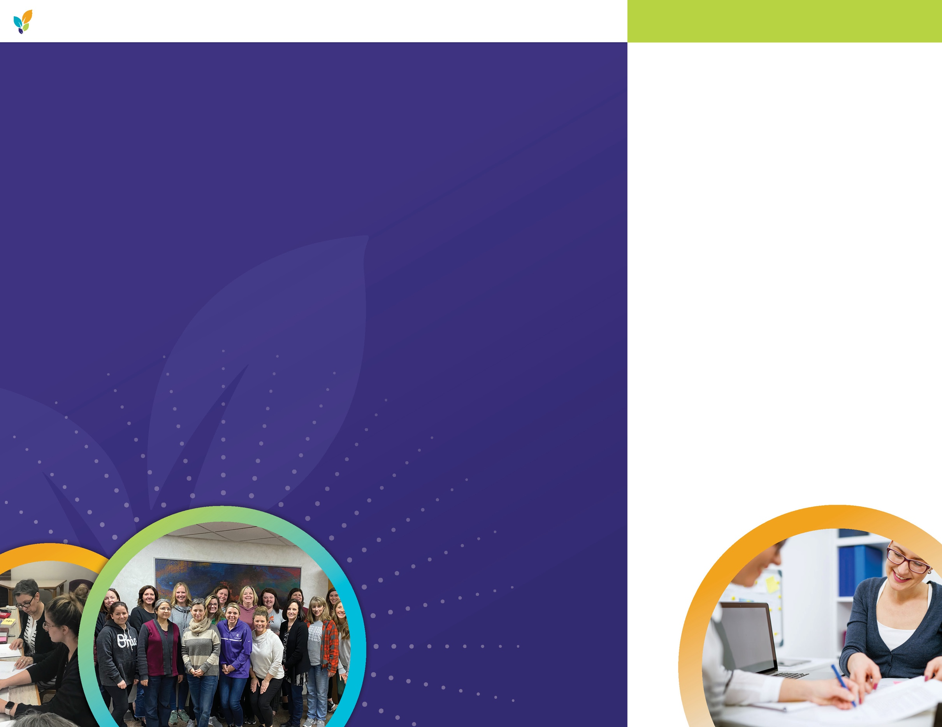

**ACCREDITED EDUCATOR TRAINING COURSES THROUGH THE CDC**

The CDC prepares adults to teach children how to read and write using the science of reading principles. The CDC courses follow a multisensory structured language/literacy education (MSLE) approach. MSLE approaches follow a systematic, sequential order and use simultaneous visual, auditory, and tactile-kinesthetic techniques.

Our courses are accredited by the International Multisensory Structured Language Education Council (IMSLEC©) at the Teaching/Practitioner, Instructor of Teaching/Practitioner, Therapy, and Instructor of Therapy levels. Educators and other qualified individuals can receive training to become certified in our IMSLEC© accredited courses. IMSLEC© courses have accreditation from the International Dyslexia Association (IDA) at the Accreditation**PLUS** level.

**THE LONG-TERM EFFECTS**

The long-term effects for those who do not receive help for dyslexia are vast and societal costs are measured in the billions each year.

Improving access to effective interventions for children will prevent many negative outcomes associated with dyslexia.

**EFFECTS OF DYSLEXIA**

**ON INDIVIDUALS**

Researchers estimate 5-20% of the U.S. population has dyslexia, but only about 4% of children in U.S. public schools receive educational remediation for it. That means between 500,000 and 8 million children do not receive specialized instruction in school.­

**EDUCATOR TRAINING**

**AT-A-GLANCE**

* Educators and other qualified individuals can receive training to become certified in our IMSLEC© accredited courses.
* Applicants must have a bachelor’s degree or higher.
* The initial course, Dyslexia Practitioner-1, includes 90 course hours, 100 hours of supervised practicum, course readings, and assignments. It takes a minimum of nine months to complete.
* As part of the Practitioner-1 training, course participants will provide individualized instruction to two children at a CDC site as part of a supervised practicum.
* Upon completion of the Practioner-1 course, instructors may recommend people for the Practitioner-2 course.
* Upon completion of the

Practitioner-2 course, instructors may recommend people for the Therapy course.

* Internships to become certified instructors to teach each course are available to those recommended by their instructors.

**ChildrensDyslexiaCenters.org**

**CHILDREN’S DYSLEXIA CENTERS**