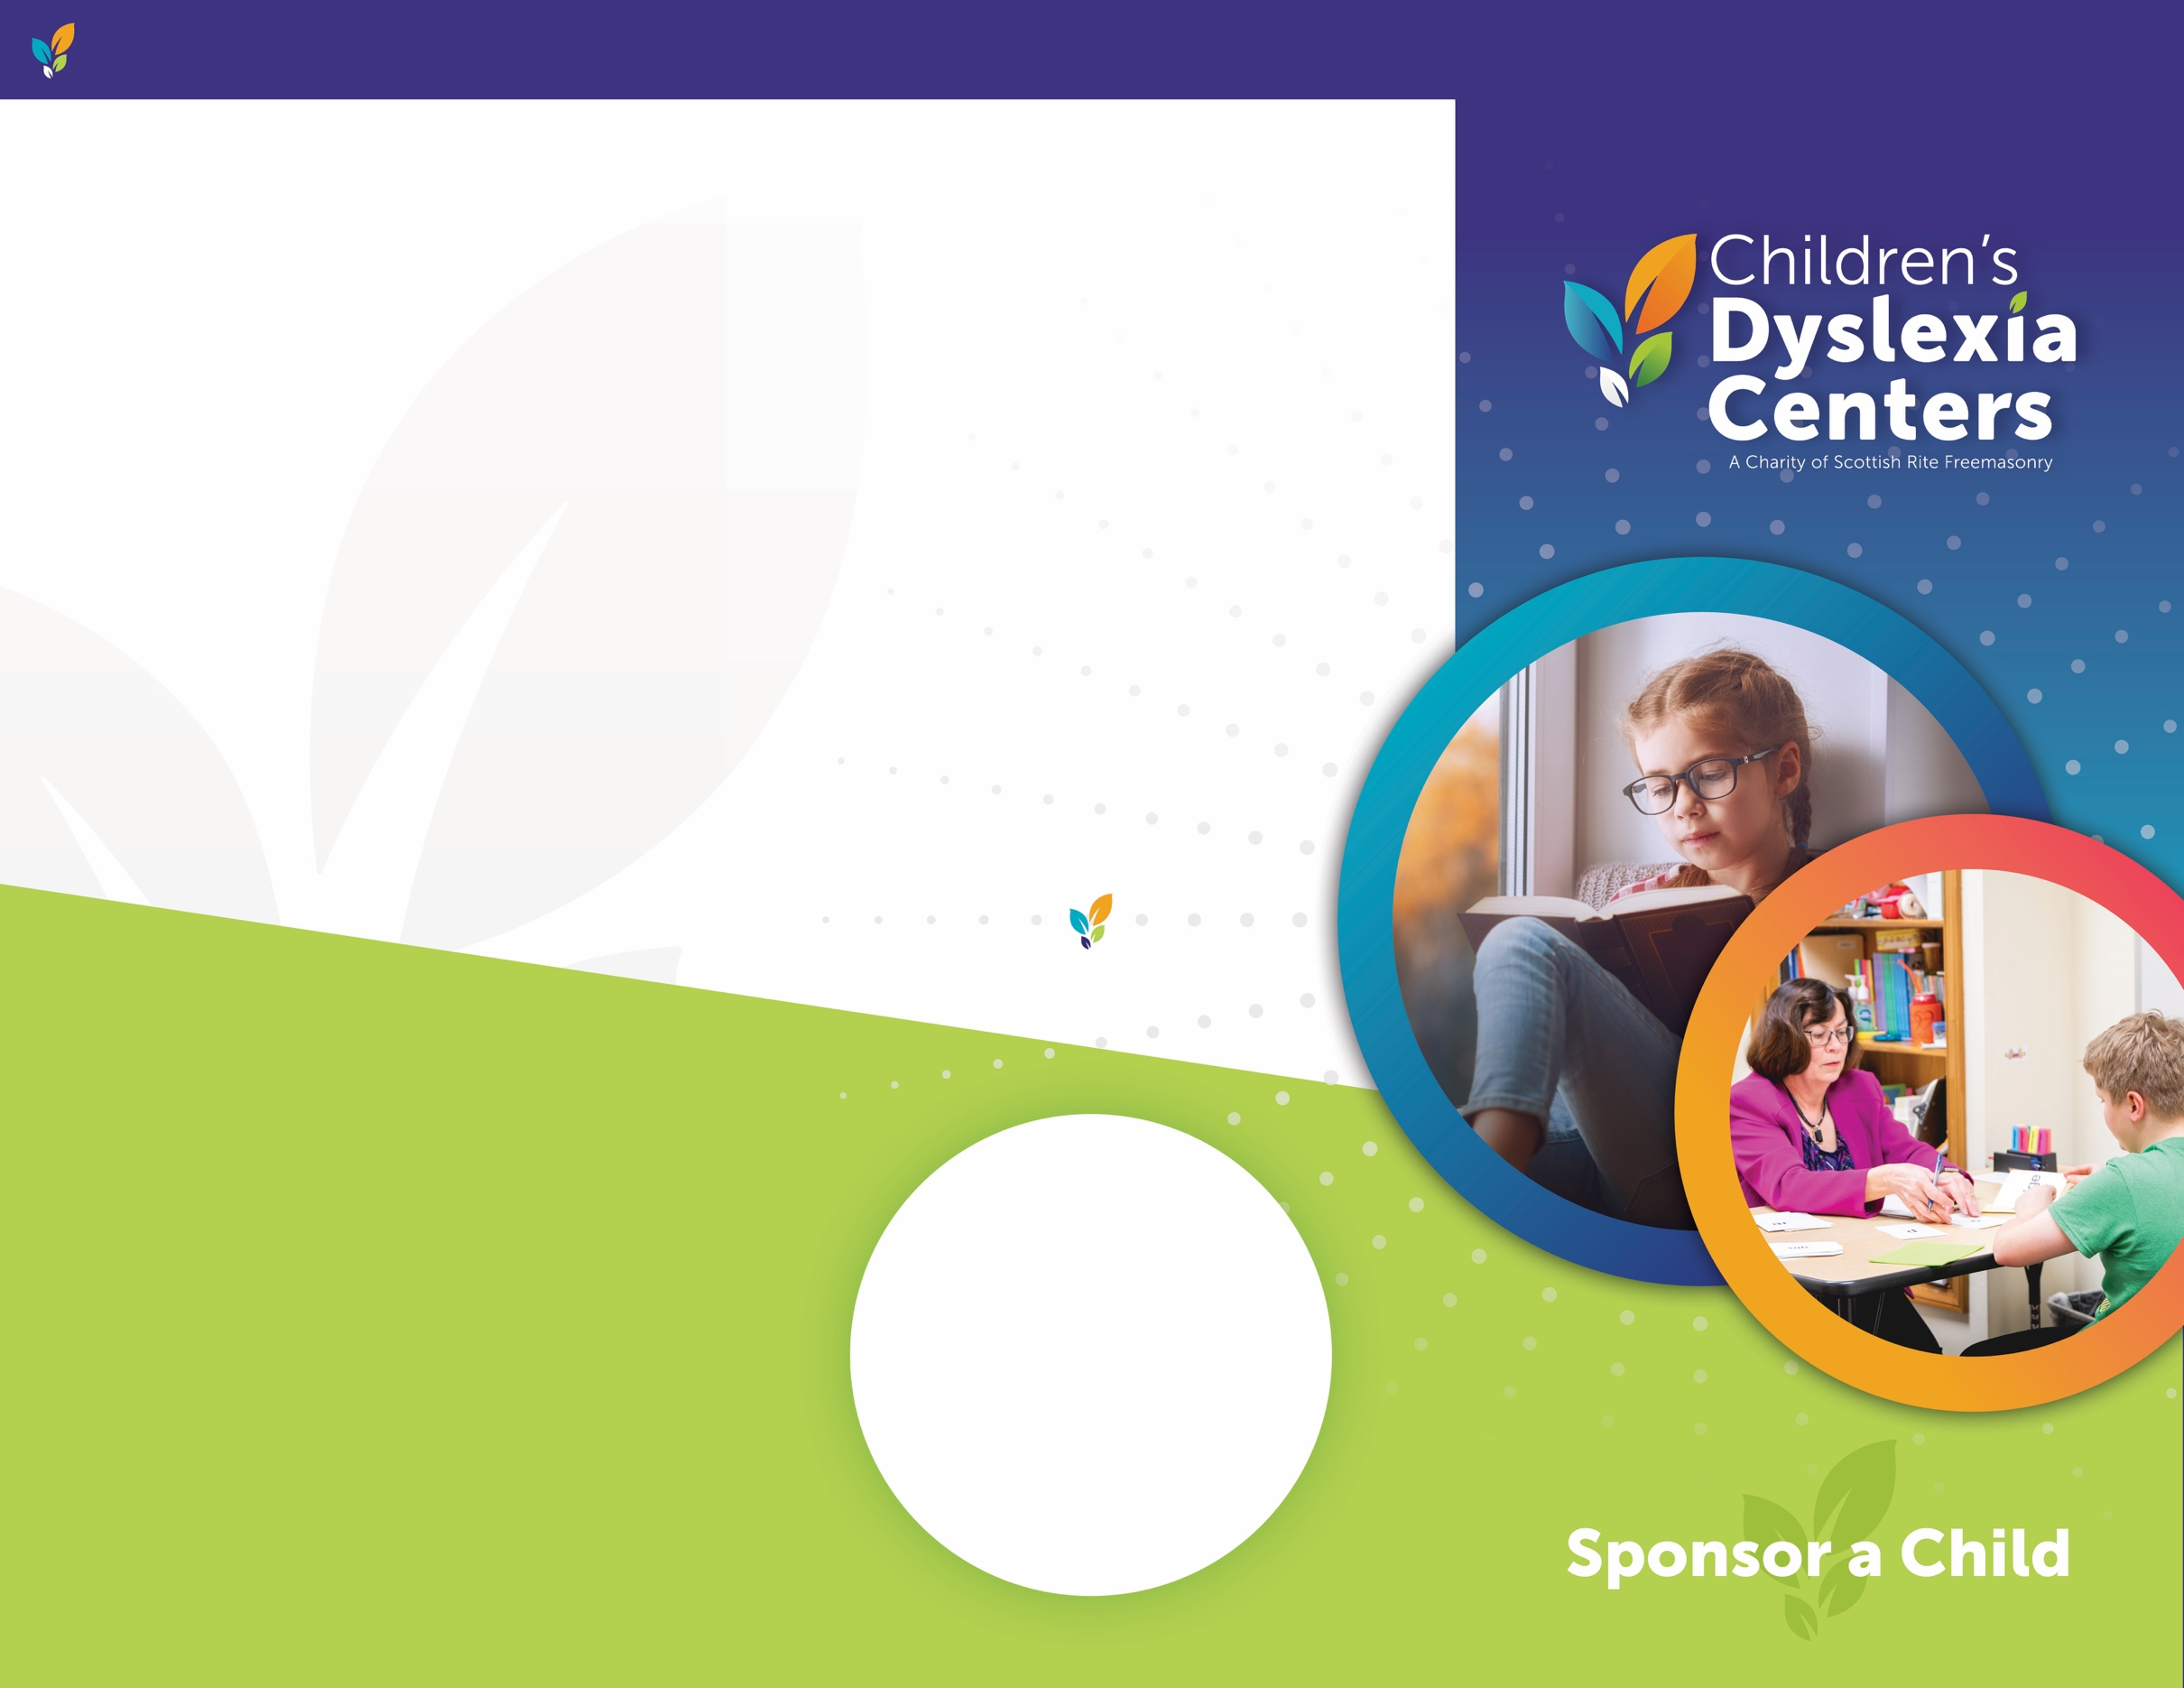s s

**START A SPONSORSHIP TODAY!**

Thanks to our committed supporters, the Children’s Dyslexia Centers are providing these essential, life-changing services at little to no cost to families.

To learn more about our Sponsor A Child program, and for more ways you can help support the work of the Children’s Dyslexia Centers, please visit ChildrensDyslexiaCenters.org or reach out to our Office:

**SUCCESS, ONE STAR AT A TIME…**

Since 1994, the Children’s Dyslexia Centers have opened doors to success for thousands of children, freeing them from a life of poor academic performance and low self-esteem.

Enrollment is open to children ages 6-18 with dyslexia. Students meet for tutoring sessions with their certified dyslexia remediation tutor twice a week to develop the literacy skills needed to succeed in school and reach their full potential.

**ChildrensDyslexiaCenters.org**

**CHANGING LIVES**

*“Anna started out far below grade level, but now she is reading and writing as well as many of her peers. Through the dedicated staff at the Children’s Dyslexia Center, Anna has received amazing tools for her journey and* ***knows*** *that she can attain victory in her quest to read and write successfully.”*

**CONTACT**

**Jocelyn Wallace**

(781) 465-3343

[JWallace@cdcinc.org](mailto:JWallace@cdcinc.org)

33 Marrett Road

Lexington, MA 02421

**CHILDREN’S DYSLEXIA CENTERS, INC. – SPONSOR A CHILD**

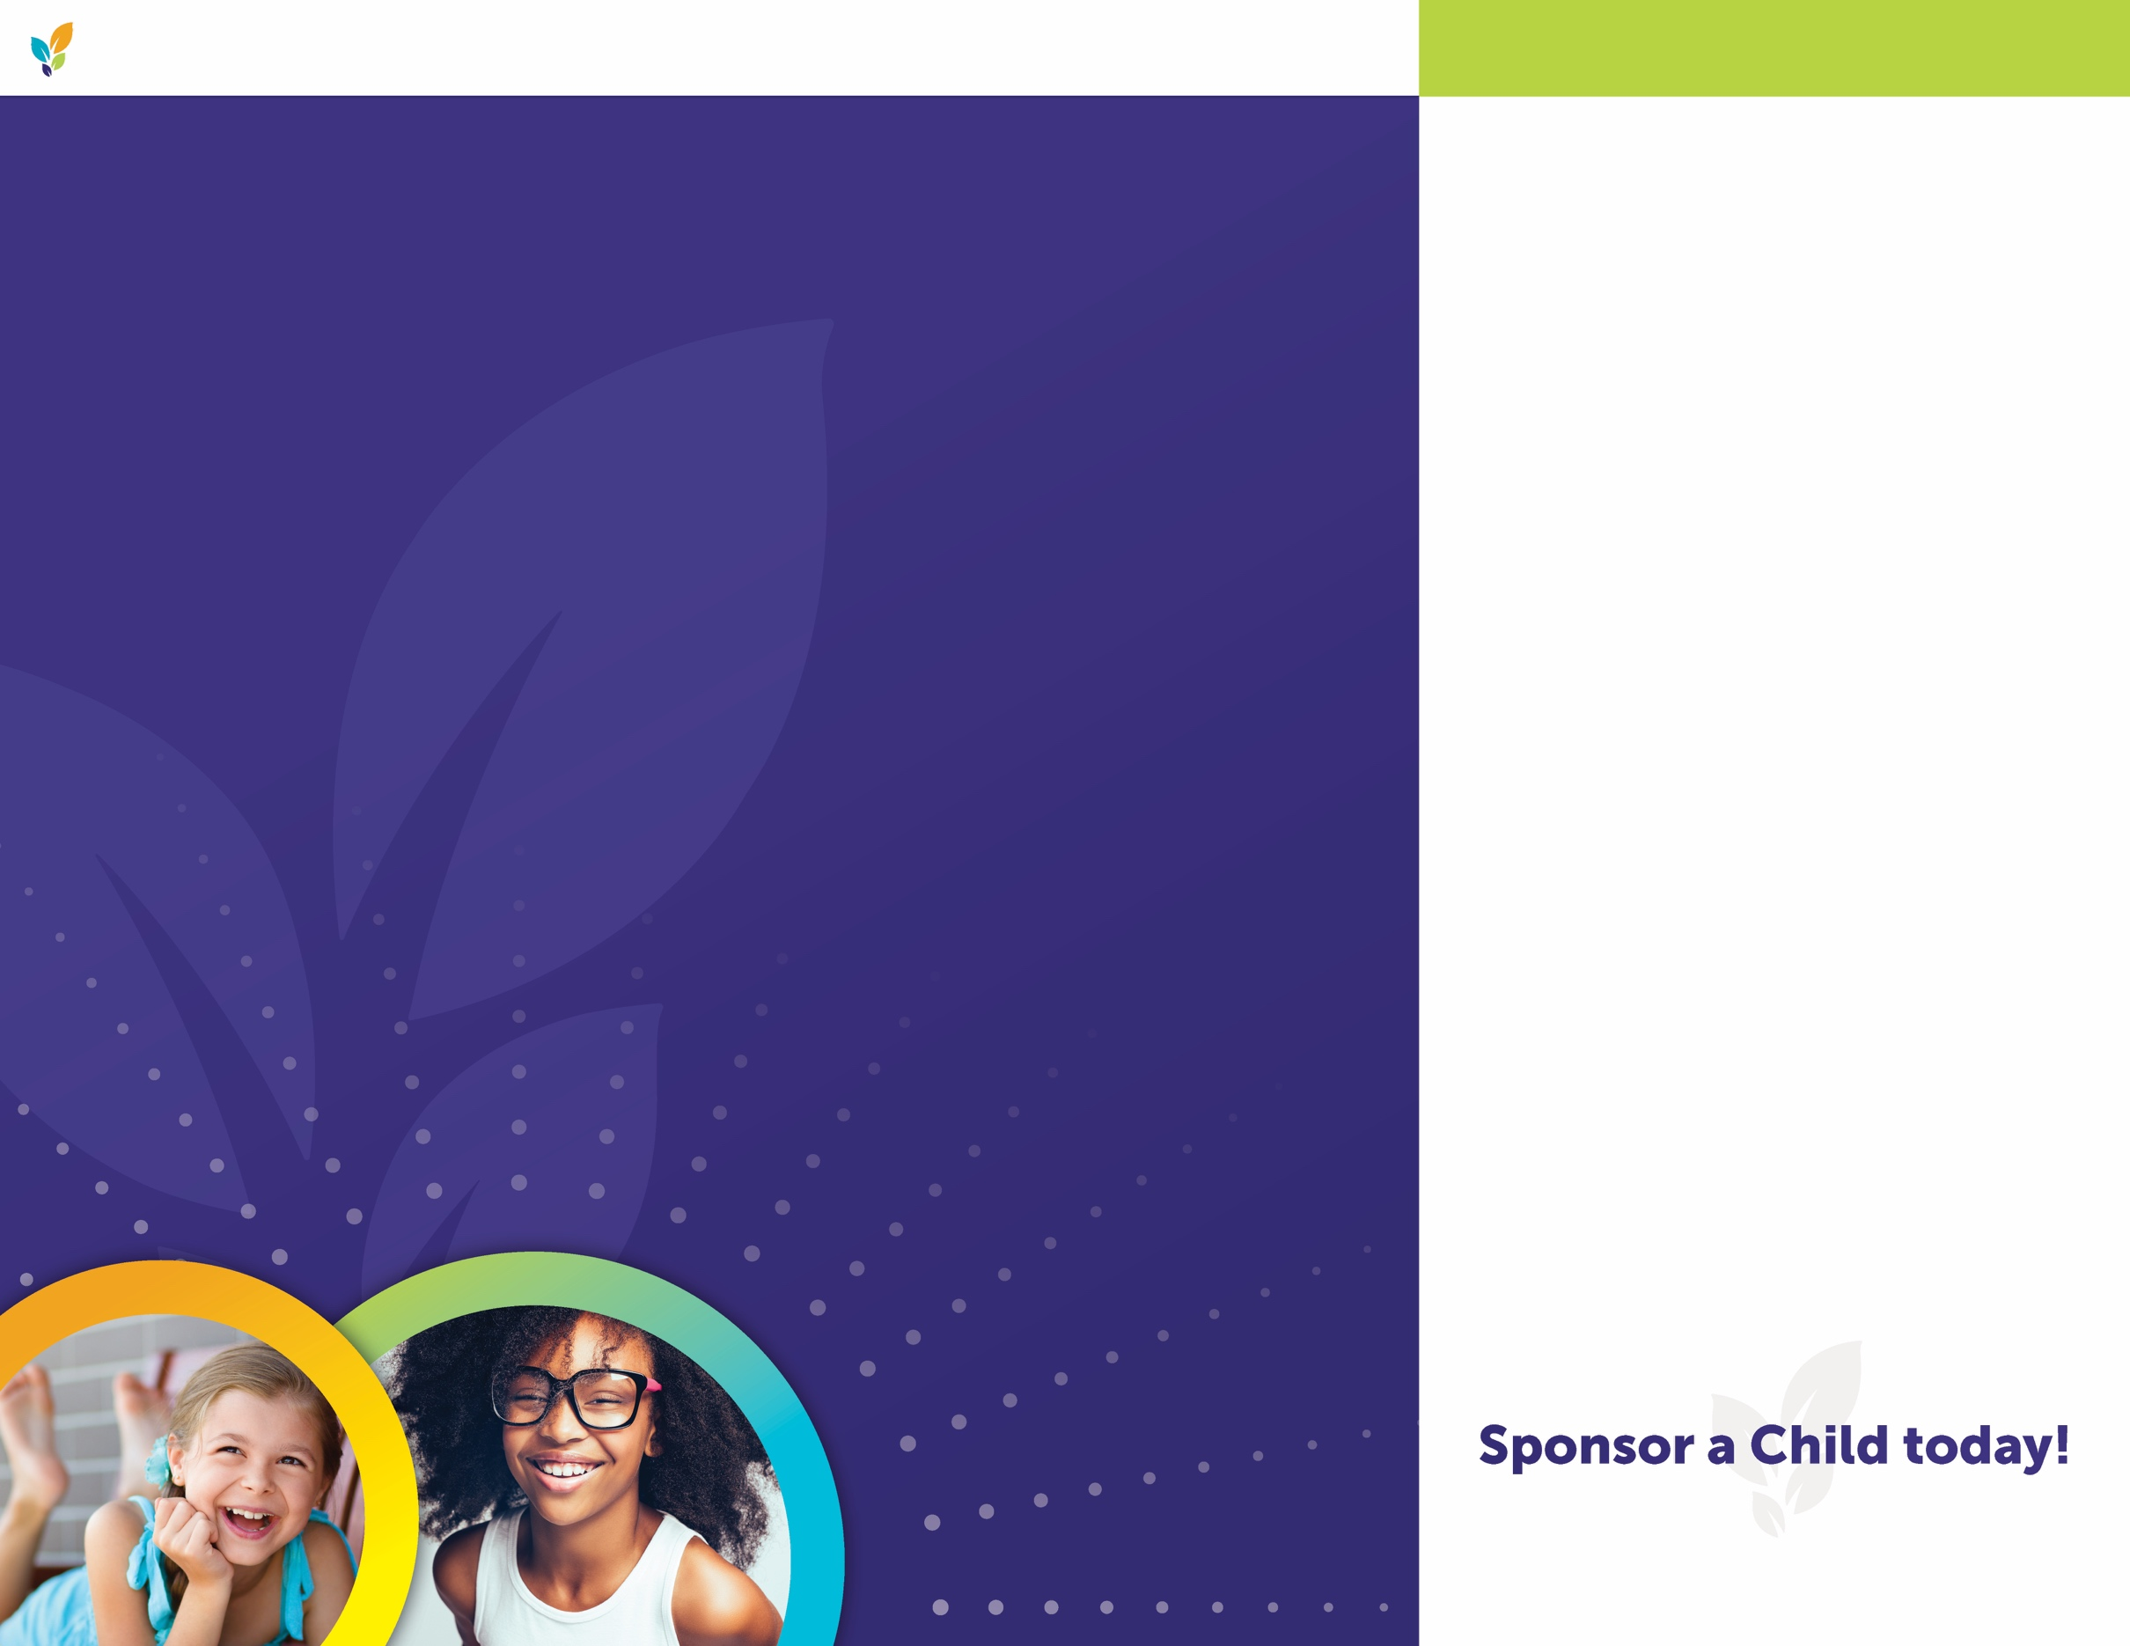

**EVERY CHILD IS A STAR…**

Imagine being one of the nearly twenty percent of schoolchildren with dyslexia, a learning difference that makes it difficult to read, write, and spell. When students with dyslexia aren’t given the proper tools, the disorder has the potential to darken even the brightest stars.

Consider Anna, an energetic child who had hit a wall when it came to reading and writing. As her mother recalls:

***“Each day brought more upsets and deepening realization that something just was***

***not right. Why couldn’t Anna learn to read? And who could help us teach our child before she completely gave up trying?”***

Dyslexia is not curable – but it can be overcome successfully. This miracle is happening daily at the Children’s Dyslexia Centers.

**YOU CAN MAKE A STAR SHINE…**

The Children’s Dyslexia Centers work with students one-on-one, allowing each lesson plan to be individually tailored to their specific needs. It costs $5,000 to provide this level of personalized care to a child for one year – but the results are priceless.

While working with their designated tutor, students see their reading and writing skills improve but even more importantly, their self-confidence and sense of well-being grow.

You can help the Dyslexia Centers accomplish this important work. With your $5,000 tax-deductible donation, you can become a sponsor and help a child like Anna learn to read and write like their peers.

**SUPPORT**

All proceeds directly support children’s dyslexia remediation tutoring, so you can be confident that your donation is going where it should– to the children who need it most.

**SPONSOR A CHILD**

Through a $5,000 sponsorship or $2,500 co-sponsorship, you can help support the tutoring costs of one child for a year.

***As a sponsor, you will receive:***

A letter featuring the first name of the child you are sponsoring;

Periodic reports on the child’s progress;

A framed Certificate of Sponsorship;

A commemorative star with your name to be displayed at the Center.

**ChildrensDyslexiaCenters.org**

**CHILDREN’S DYSLEXIA CENTERS, INC. SPONSOR A CHILD**