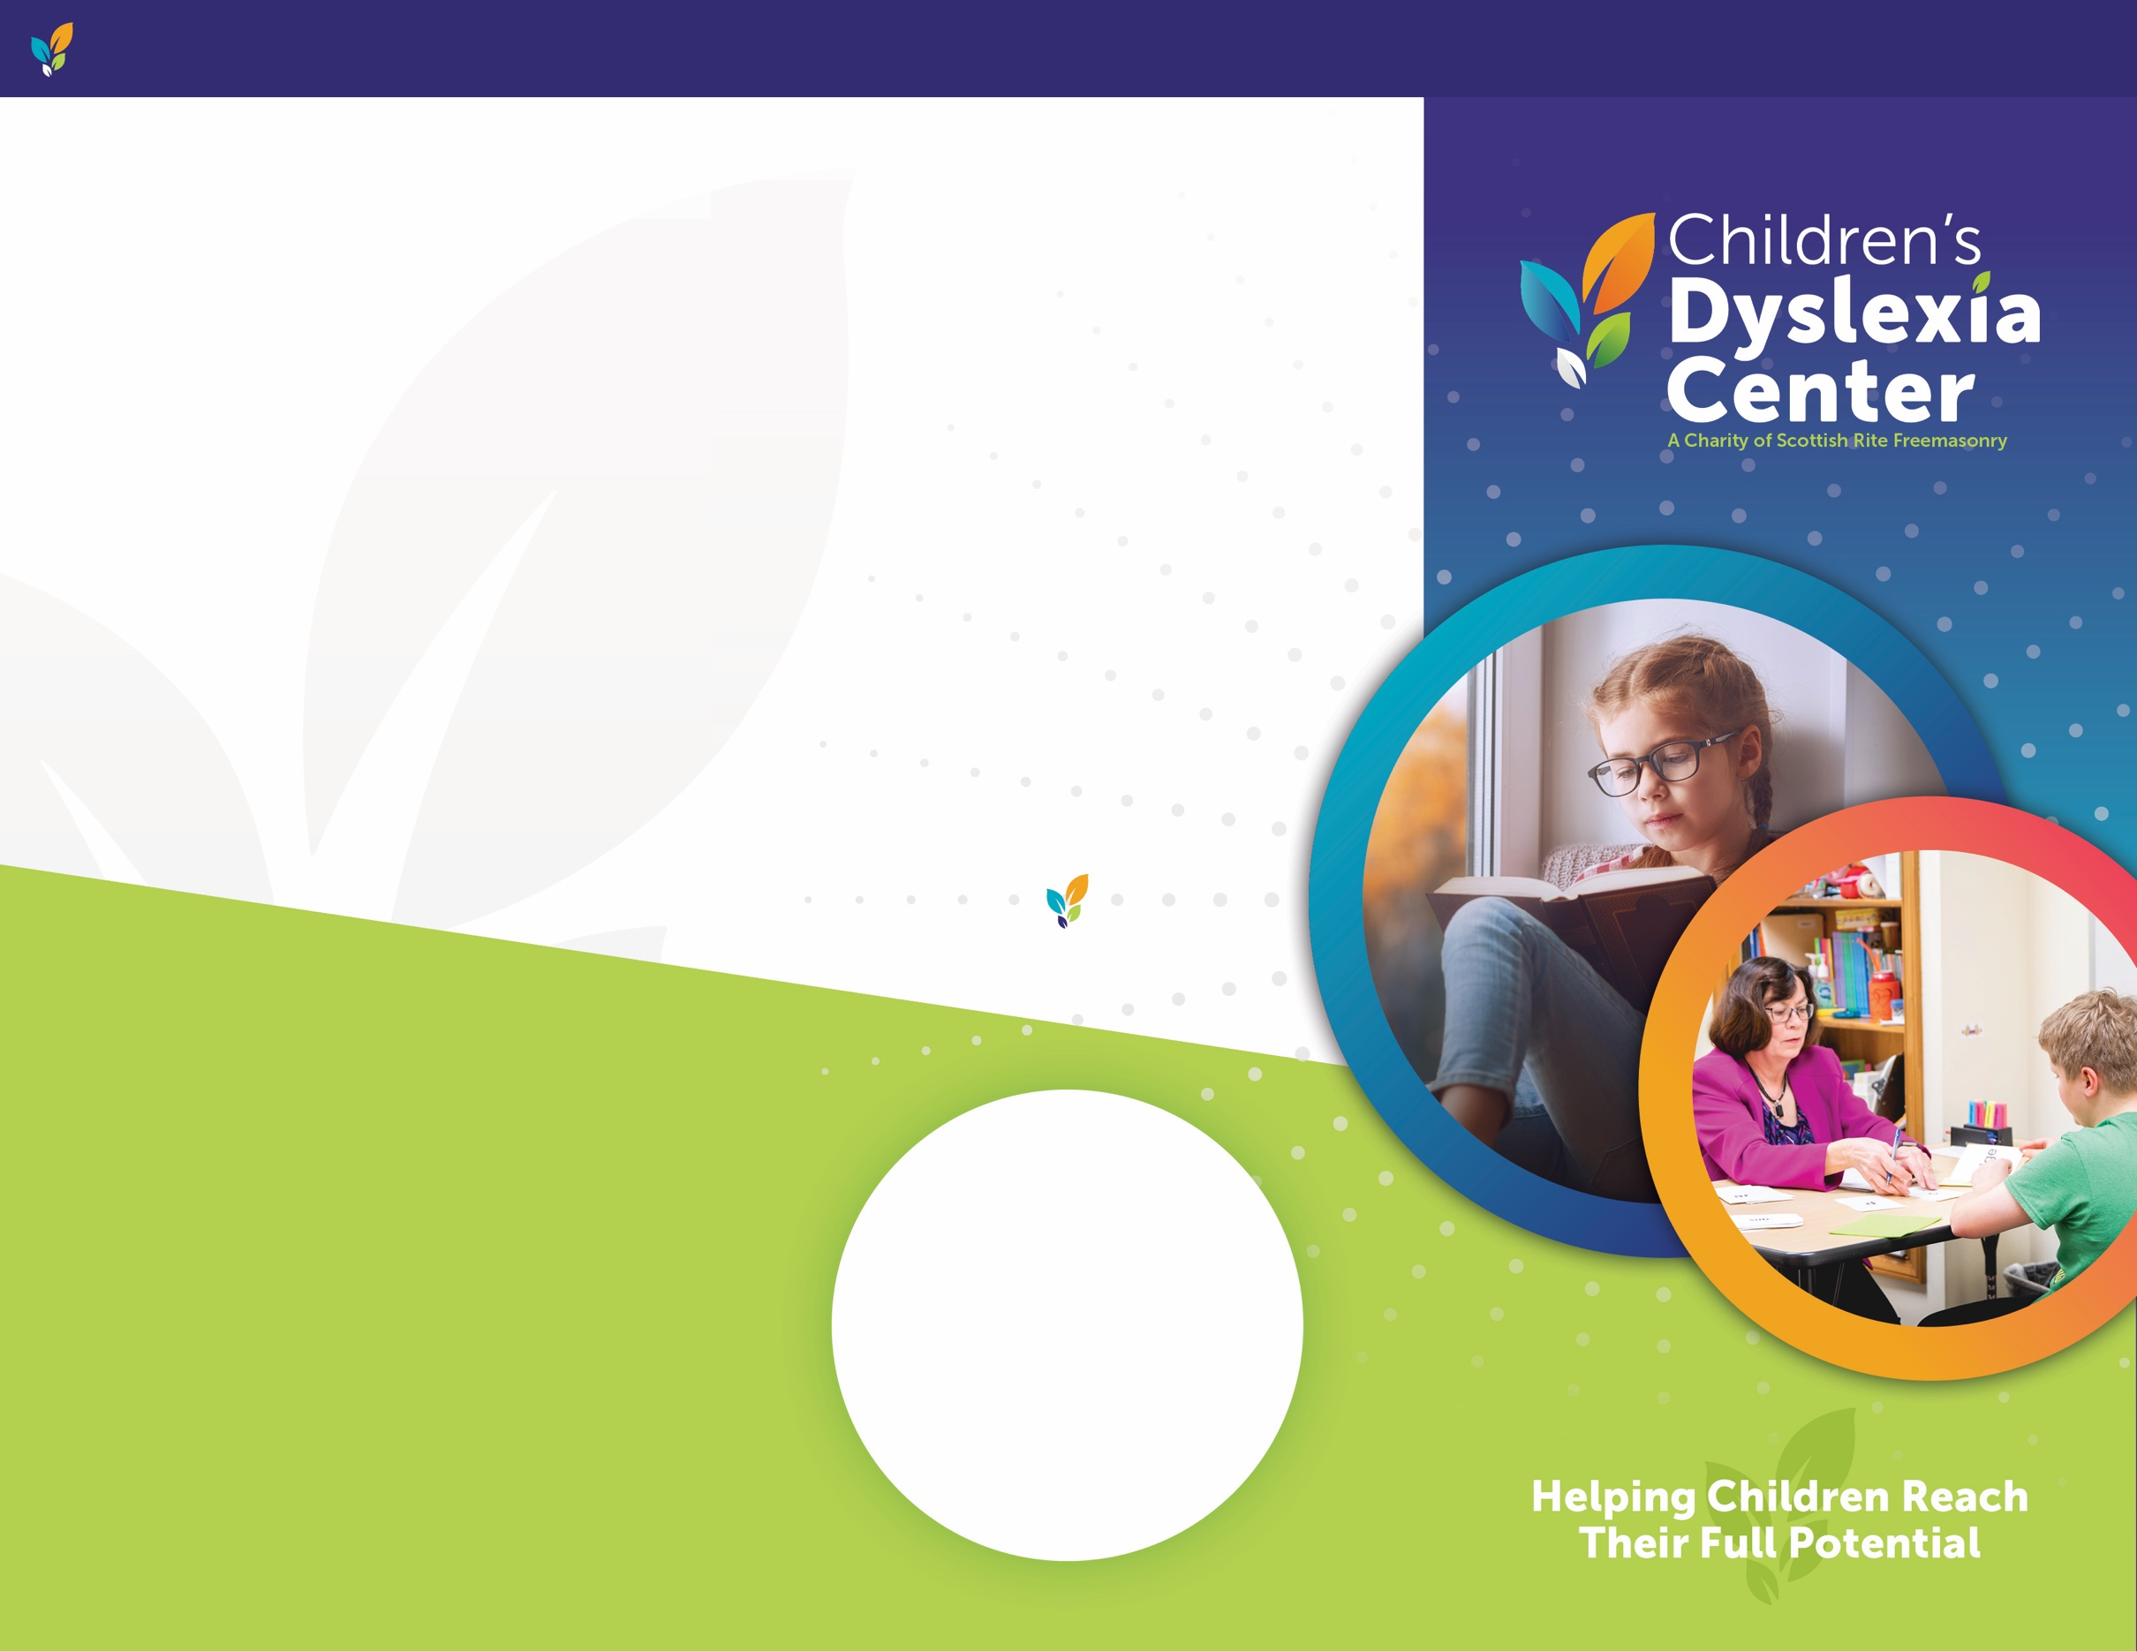s

**WHO WE ARE**

We belong to a family of tutoring Centers across 13 states. We provide **FREE / REDUCED COST** literacy intervention for children living with dyslexia. Our program is supplying children with the reading skills they need to excel while building the next generation of dyslexia intervention specialists through our nationally accredited training program.

Since 1994, our Children’s Dyslexia Centers have changed the lives of 14,000 children and trained over

3,500 educators.

**ChildrensDyslexiaCenters.org**

**WAYS TO GIVE**

The success of our Center is due to the dedication and involvement of volunteers, board members, and generous donors, as well as our professional staff, tutors, and trainees.

You can support our life-changing work and help children in our community discover the gift of reading today at: **ChildrensDyslexiaCenters.org/Donate**

To learn more about our donor programs, visit our website or contact our Center Director listed below.

**CHANGING LIVES**

*“The Dyslexia Center has had such a positive impact on our daughter. We tried several avenues to help her with her reading, and they all failed. Reading would bring her to tears.*

*After just 7 months at the Center, her reading has improved dramatically. The little girl that once cried when she had to read is now reading chapter books for fun.”*

-A Grateful Parent

**CONTACT**

**Firstname Lastname**

123-456-7890

Email

Address Line 1

Address Line 2

City, St Zip

**CITY NAME HERE**

**CITY NAME CHILDREN’S DYSLEXIA CENTER**

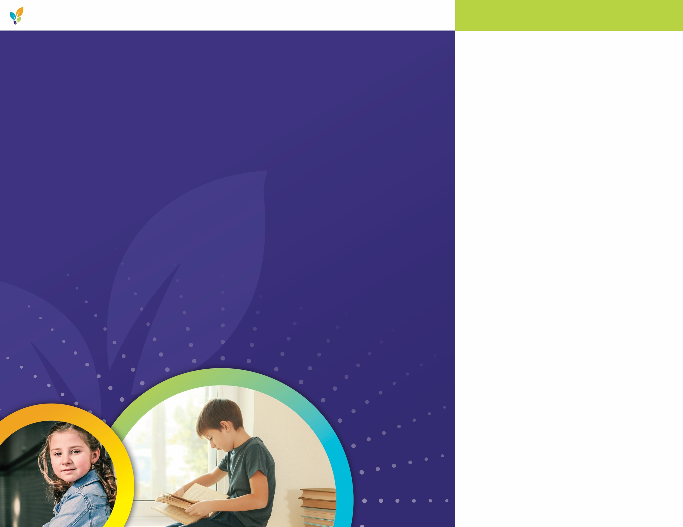

**WHAT WE DO**

The Children’s Dyslexia Centers are equipping students with the skills and confidence they need to approach learning with eagerness and without fear.

Our dedicated educators make a difference in the lives of children with dyslexia every day through their work. The mission of each Dyslexia Center has three components:

**ChildrensDyslexiaCenters.org**

**STUDENT EDUCATION & SUPPORT**

Provide the highest quality, state-of the art, multisensory tutorial reading and written language instruction to children with dyslexia;

**EDUCATOR CERTIFICATION**

Train tutors in the art, science and practice of tutoring children using the Orton-Gillingham approach to multisensory teaching of reading, spelling and writing;

**SCIENTIFIC RESEARCH**

Advance the body of scientific knowledge of dyslexia through support of clinical research, to improve today’s standards

and tomorrow’s care.

**WHAT IS DYSLEXIA?**

Dyslexia is a learning disability that makes it difficult for children and adults to read, write, and spell. An estimated 1 in 5 Americans have dyslexia, regardless of their intelligence or quality of education.

Without access to specialized education, students with dyslexia often fall behind their peers, which

can be detrimental to a child’s

self-esteem and overall academic achievement. Research reveals

that children with untreated dyslexia

can become underachieving adults unable to contribute to society at

their fullest capacity.

**OUR MISSION**

We are a dedicated organization of people who believe every child should have access to high-quality reading and writing instruction. We’re helping children to successfully meet the literacy demands in school and their future careers.

Since **YEAR**, the Children’s Dyslexia Centers has helped over **NUMBER** children in the **LOCATION** area discover the gift of reading, opening them up to a world of opportunities that once seemed unattainable. We have also trained over **NUMBER** local educators in best-practice approaches to teaching reading skills. The need for these services is substantial, and we are committed to helping children with dyslexia in our community reach their full potential.

**CITY NAME CHILDREN’S DYSLEXIA CENTER**